

**Object Oriented Programming Lab**

**Name:** Pratham Kandari

**Sap Id:** 500097663

**Batch:** 7

**Experiment -2**

**Title:** Basic Java Programming

1. Write a program to find the largest of three numbers.

Soln:

import java.util.*;

class ExpTwoOne

{

public int Largest(int a,int b,int c)

{

if(a>b && a>c && a!=b && a!=c)

{

return a;

}

else if(b>a && b>c && b!=a && b!=c)

{

return b;

}

else if(c>a && c>b && c!=a && c!=b)

{

return c;

}

else

{

return 0;

}

}

public static void main(String args[])

{

Scanner sc=new Scanner(System.in);

System.out.println("Enter three numbers");

int x=sc.nextInt();

int y=sc.nextInt();

int z=sc.nextInt();

ExpTwoOne ob=new ExpTwoOne();

int p=ob.Largest(x,y,z);

System.out.println("The largest no is " +p);

}

}

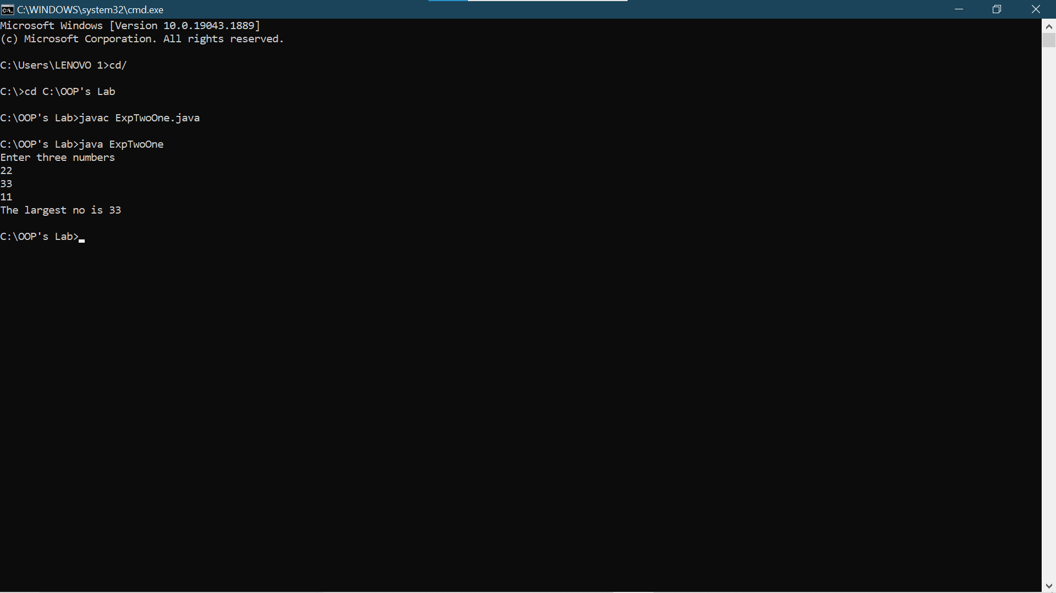

1. Write a program to implement a command line calculator. (Try for Add sub Mul Division in the same program for 2 digits ).

Soln:

import java.util.*;

class Calc{

public static void main(String args[])

{

int a = Integer.parseInt(args[0]);

int b= Integer.parseInt(args[2]);

char ch=args[1].charAt(0);

if(ch=='+')

System.out.println(a+b);

else if(ch=='x')

System.out.println(a+b);

else if(ch=='-')

System.out.println(a-b);

else if(ch=='/')

System.out.println(a/b);

else

System.out.println("not def");

}

}

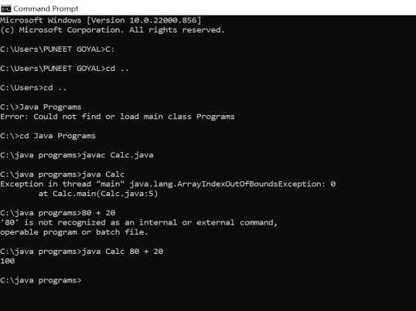

1. Write a program to accept 10 student’s marks in an array, arrange it into ascending order, convert it into the following grades, and print marks and grades in tabular form.

Between 40 and 50 : PASS

Between 51 and 75 : MERIT

and above : DISTINCTION

**Soln:**

import java.util.*;

class ExpTwoThree

{

public static void main(String args[])

{

Scanner sc = new Scanner(System.in);

int a[]=new int[10];

int i=0,j=0;

System.out.println("Enter the Marks");

for(i=0;i<10;i++)

{

a[i]=sc.nextInt(); // Input of the marks of 10 students

}

for(i=0;i<10;i++) // Sorting using Bubble Sort

{

for(j=0;j<9-i;j++)

{

if(a[j]>a[j+1])

{

int t=a[j];

a[j]=a[j+1];

a[j+1]=t;

}

}

}

System.out.println("Sorted array");

for(i=0;i<10;i++)

{

System.out.print(a[i]+" ");

}

System.out.println();

for(i=0;i<10;i++)

{

if(a[i]>40 && a[i]<50)

{

System.out.println(a[i]+" "+"Pass");

}

else if(a[i]>51 && a[i]<75)

{

System.out.println(a[i]+" "+"Merit");

}

else if(a[i]>75)

{

System.out.println(a[i]+" "+"DISTINCTION");

}

else

{

System.out.println(a[i]+" "+"Fail");

}

}

}

}

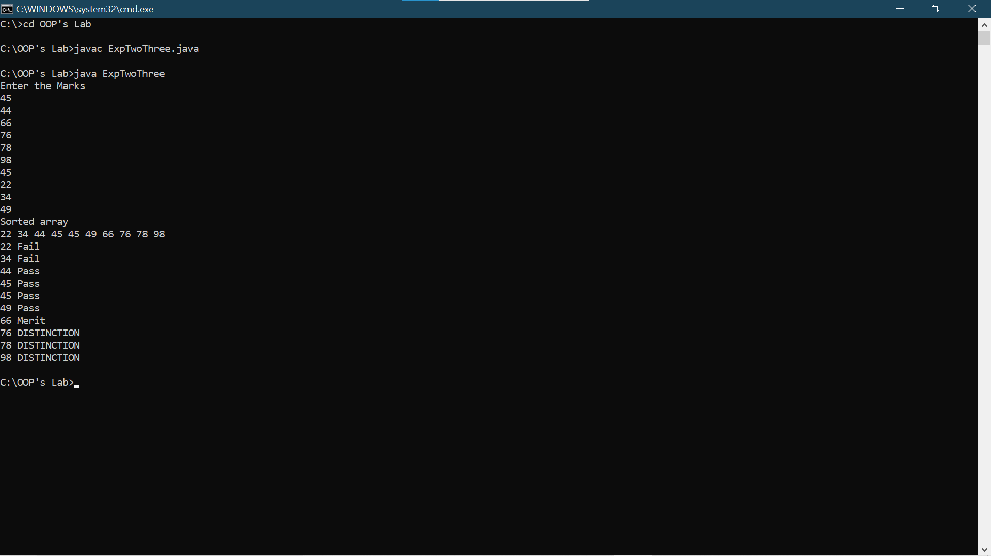

1. WAP to Take input as DD MM YYYY(04 08 2021) in command line and calculate number of days since 1 January 1970.

Soln:

public class Calender{

public static void main(String args[]){

int d=Integer.parseInt(args[0]);

int m=Integer.parseInt(args[1]);

int y=Integer.parseInt(args[2]);

int rd=0;

int rm=0;

int ry=0;

if (y>=1970)

{

ry=(y-1970)*360; rm=(m-1)*30;

rd=d-1; System.out.println(ry+rm+rd);

}

else

{

System.out.println("Invalid date");

}

}

}

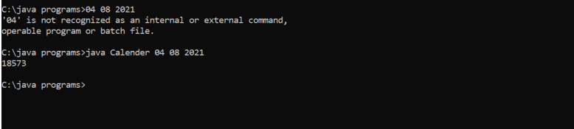

1. WAP to print the following pattern using loops

*

***

*****

**Soln:**

class ExpTwoFive

{

public static void main(String args[])

{

int i=0,j=0;

int st=1;

for(i=1;i<=3;i++)

{

for(j=1;j<=st;j++)

{

System.out.print("*");

}

st=st+2;

System.out.println();

}

}

}

